Module 4
Assignment 1
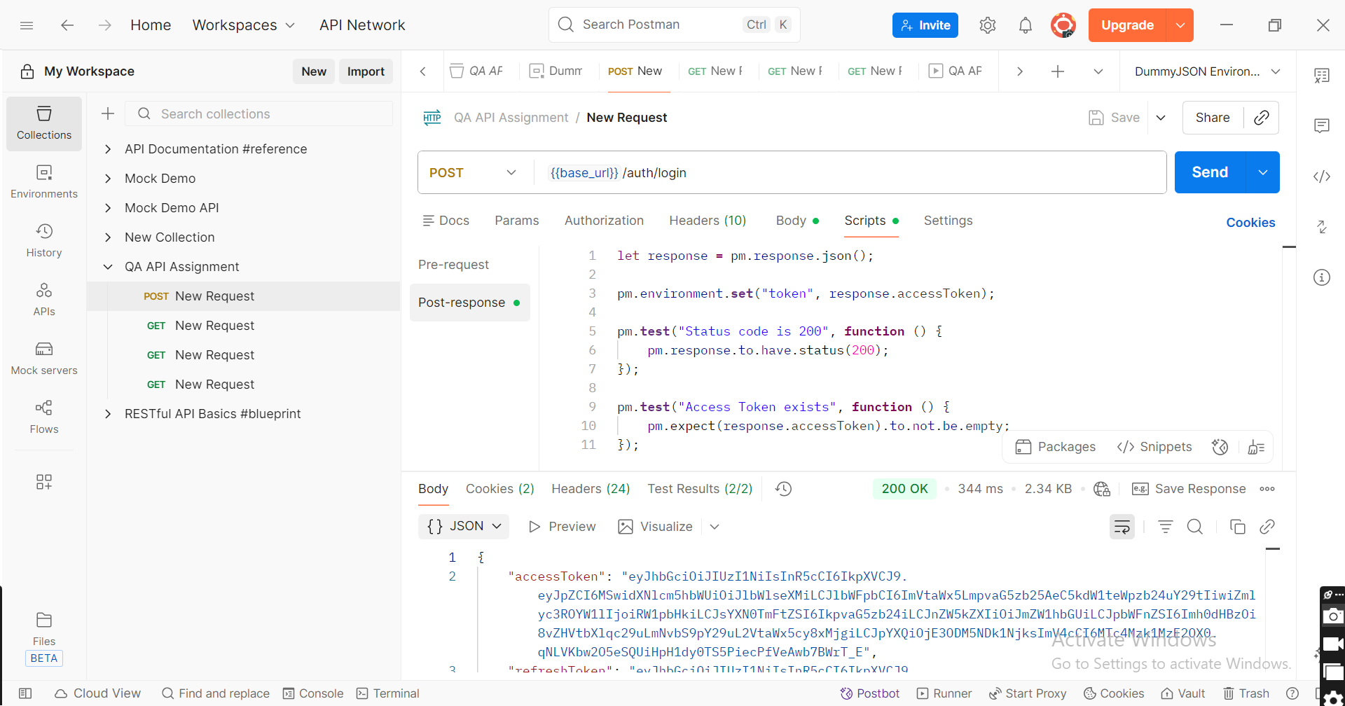
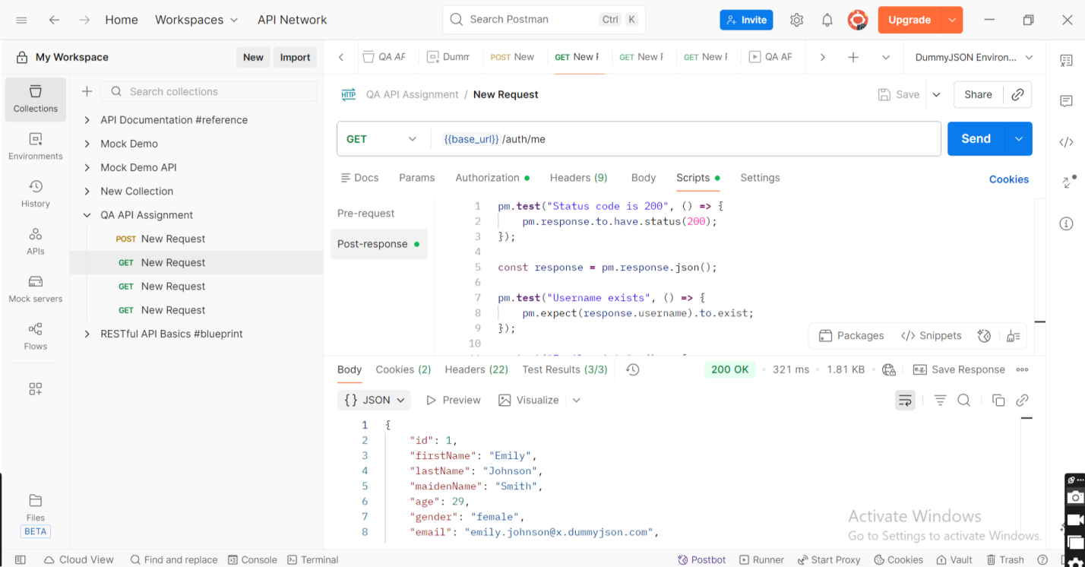
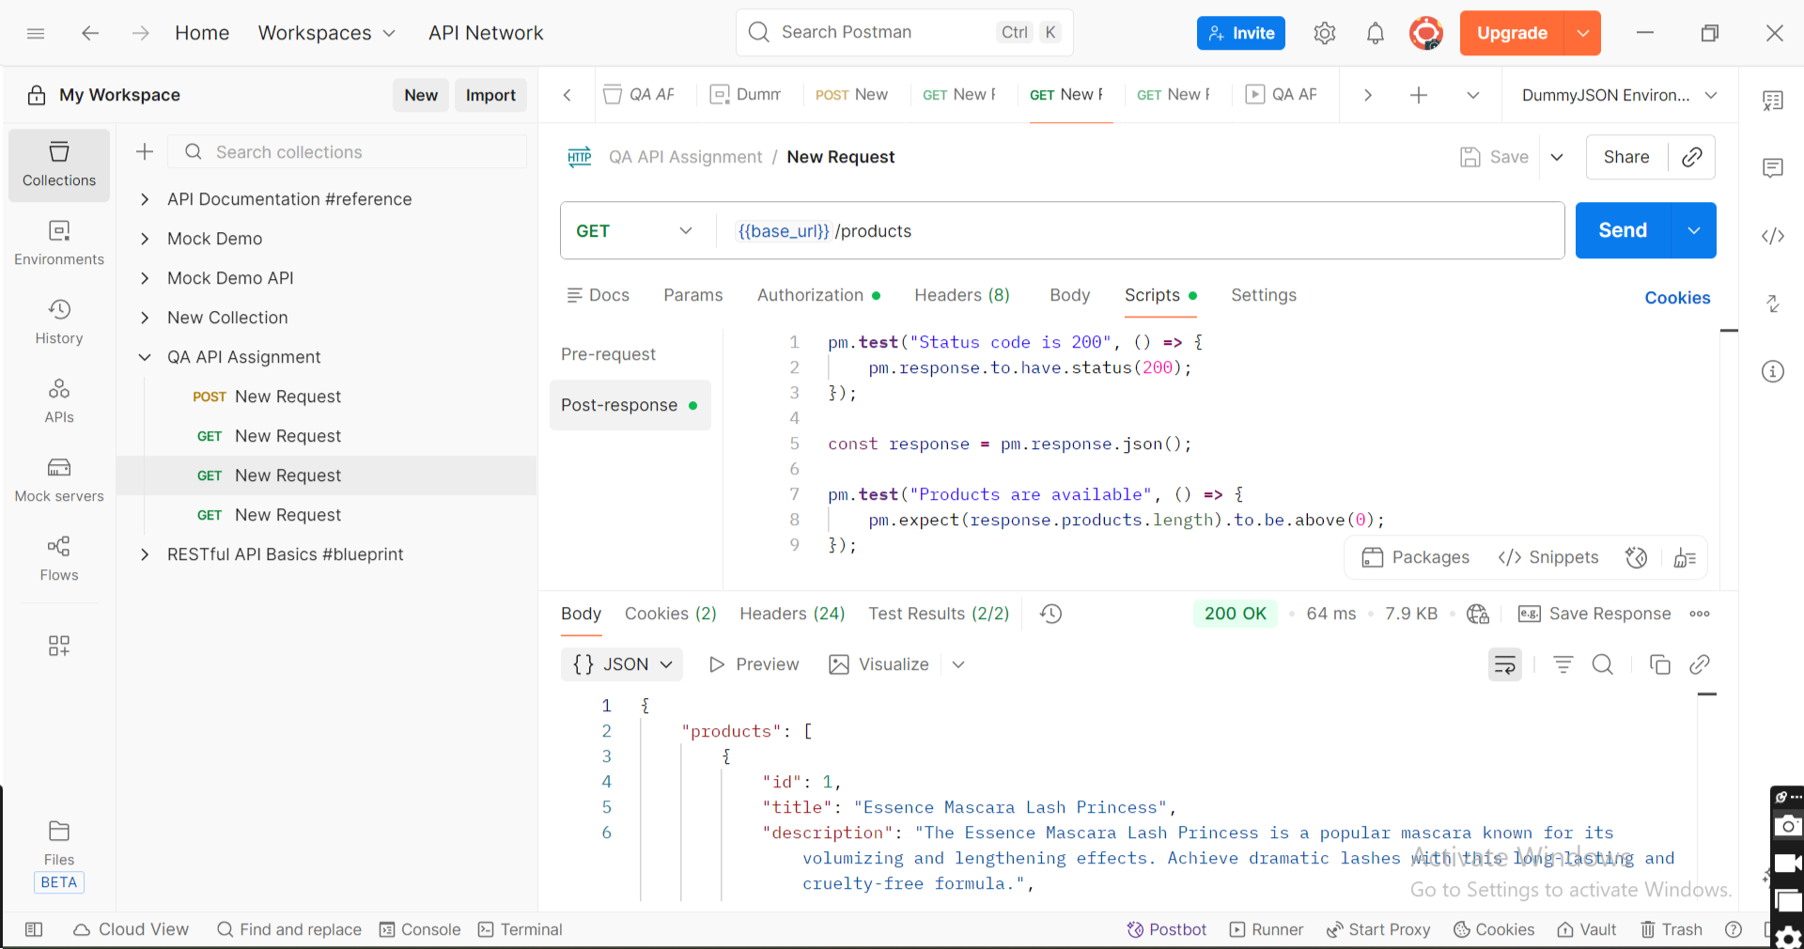
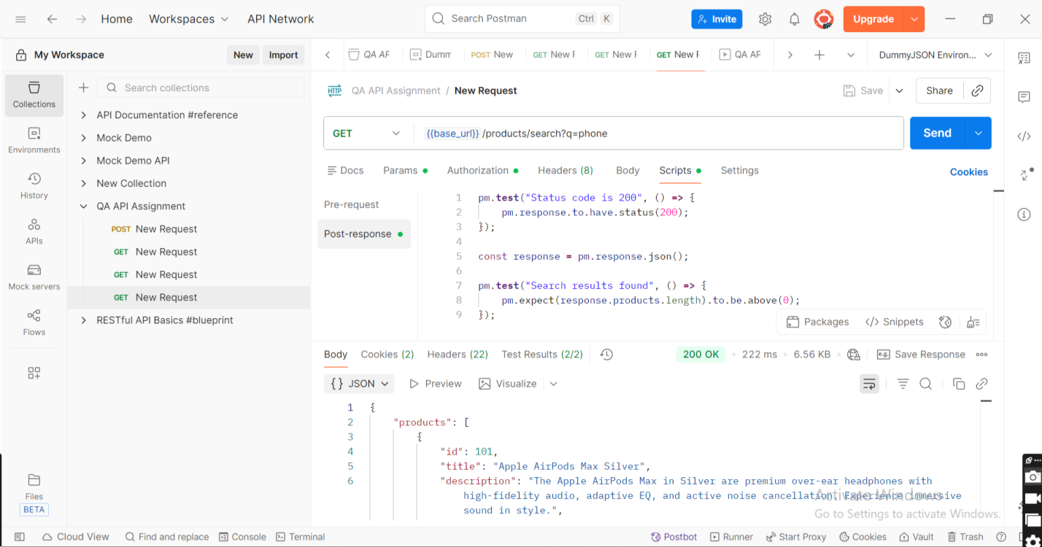
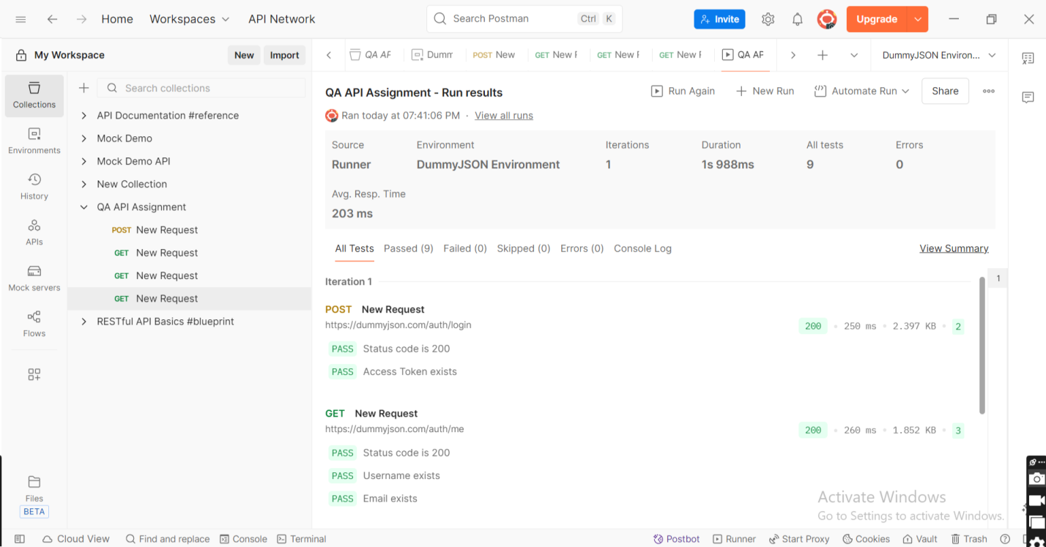
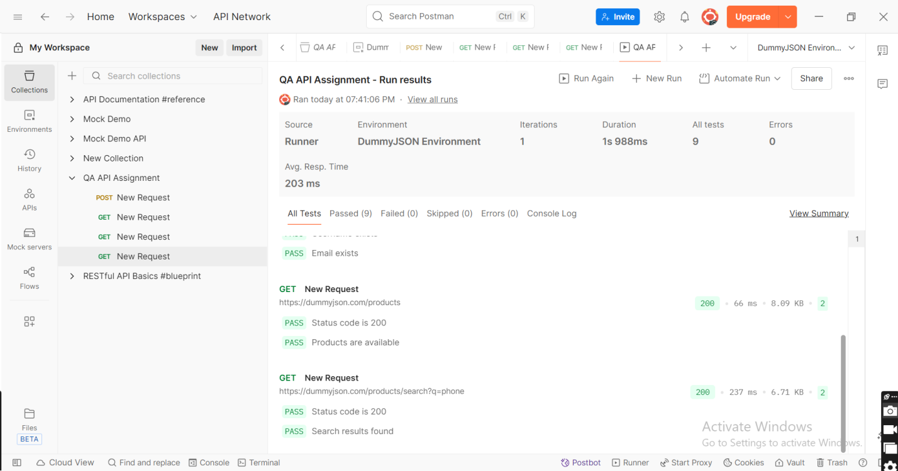
Assignment 2
OrangeHRM is taken for DEMO
config.py
URL = "https://opensource-demo.orangehrmlive.com/web/index.php/auth/login"

USERNAME = "Admin"
PASSWORD = "admin123"
BROWSER = "chrome"
POM:
login_page.py
from selenium.webdriver.common.by import By
from selenium.webdriver.support.ui import WebDriverWait
from selenium.webdriver.support import expected_conditions as EC

class LoginPage:
def __init__(self, driver):
self.driver = driver
self.wait = WebDriverWait(driver, 10)
username = (By.NAME, "username")
password = (By.NAME, "password")
login_button = (By.XPATH, "//button[@type='submit']")
def enter_username(self, username):
self.wait.until(
EC.visibility_of_element_located(self.username)
).send_keys(username)
def enter_password(self, password):
self.wait.until(
EC.visibility_of_element_located(self.password)
).send_keys(password)
def click_login(self):
self.wait.until(
EC.element_to_be_clickable(self.login_button)
).click()
def login(self, username, password):
self.enter_username(username)
self.enter_password(password)
self.click_login()

dashboard_page.py
from selenium.webdriver.common.by import By
from selenium.webdriver.support.ui import WebDriverWait
from selenium.webdriver.support import expected_conditions as EC

class DashboardPage:
def __init__(self, driver):
self.driver = driver
self.wait = WebDriverWait(driver, 10)
dashboard_heading = (By.XPATH, "//h6[text()='Dashboard']")
search_box = (
By.XPATH,
"//input[@placeholder='Search']"
)
profile = (
By.XPATH,
"//span[@class='oxd-userdropdown-tab']"
)
logout_button = (
By.XPATH,
"//a[text()='Logout']"
)
def is_dashboard_displayed(self):
return self.wait.until(
EC.visibility_of_element_located(
self.dashboard_heading
)
).is_displayed()
def search(self, text):
search = self.wait.until(
EC.visibility_of_element_located(
self.search_box
)
)
search.clear()
search.send_keys(text)
def logout(self):
self.wait.until(
EC.element_to_be_clickable(
self.profile
)
).click()
self.wait.until(
EC.element_to_be_clickable(
self.logout_button
)
).click()

Tests
test_login.py
import time
from utils.logger import logger
from utils.driver_factory import get_driver
from config.config import URL, USERNAME, PASSWORD
from pages.login_page import LoginPage
from pages.dashboard_page import DashboardPage
from utils.screenshot import capture_screenshot

def test_login():
driver = get_driver()
try:
logger.info("Browser launched")
driver.get(URL)
logger.info("Application opened")
login = LoginPage(driver)
login.login(USERNAME, PASSWORD)
logger.info("Login Successful")
dashboard = DashboardPage(driver)
assert dashboard.is_dashboard_displayed()
logger.info("Dashboard Verified")
dashboard.search("Admin")
logger.info("Search Successful")
dashboard.logout()
logger.info("Logout Successful")
except Exception:
capture_screenshot(driver, "test_failed")
logger.error("Test Failed")
raise
finally:
driver.quit()
logger.info("Browser Closed")

Utils:
driver_factory.py
from selenium import webdriver
from selenium.webdriver.chrome.service import Service
from webdriver_manager.chrome import ChromeDriverManager

from config.config import BROWSER
def get_driver():
if BROWSER.lower() == "chrome":
driver = webdriver.Chrome(
service=Service(ChromeDriverManager().install())
)
else:
raise Exception("Browser not supported")
driver.maximize_window()
return driver

logger.py
import logging
import os

os.makedirs("logs", exist_ok=True)
logger = logging.getLogger("selenium_framework")
logger.setLevel(logging.INFO)
if not logger.handlers:
file_handler = logging.FileHandler("logs/test.log")
formatter = logging.Formatter(
"%(asctime)s - %(levelname)s - %(message)s"
)
file_handler.setFormatter(formatter)
logger.addHandler(file_handler)

screenshot.py
import os

os.makedirs("screenshots", exist_ok=True)
def capture_screenshot(driver, filename):
driver.save_screenshot(f"screenshots/{filename}.png")

Screenshots
test_failed.png
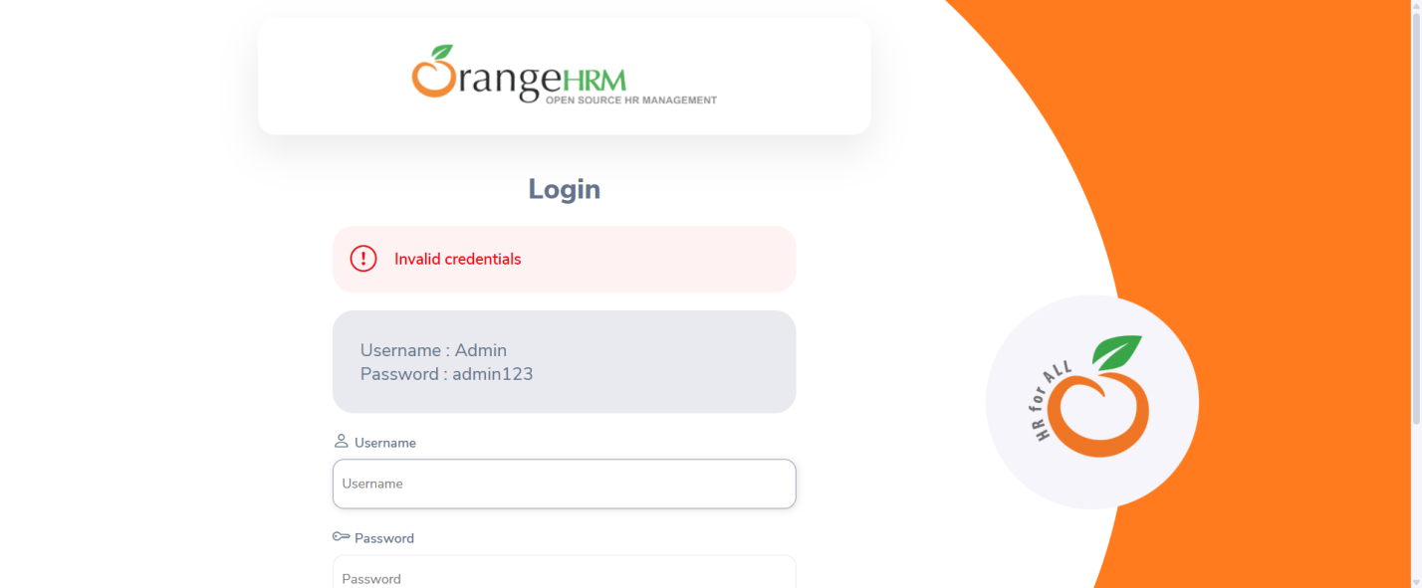
Logs
test.log
2026-07-13 23:09:58,969 - INFO - Browser launched
2026-07-13 23:10:12,680 - INFO - OrangeHRM opened
2026-07-13 23:10:14,253 - INFO - Login Successful
2026-07-13 23:10:16,267 - INFO - Dashboard Verified
2026-07-13 23:10:16,457 - INFO - Search Successful
2026-07-13 23:10:21,206 - INFO - Logout Successful
2026-07-13 23:10:29,201 - INFO - Browser Closed
2026-07-13 23:12:17,652 - INFO - Browser launched
2026-07-13 23:12:28,496 - INFO - OrangeHRM opened
2026-07-13 23:12:31,350 - INFO - Login Successful
2026-07-13 23:12:32,007 - INFO - Dashboard Verified
2026-07-13 23:12:32,237 - INFO - Search Successful
2026-07-13 23:12:36,419 - INFO - Logout Successful
2026-07-13 23:12:44,219 - INFO - Browser Closed
2026-07-13 23:15:09,037 - INFO - Browser launched
2026-07-13 23:15:19,573 - INFO - Application opened
2026-07-13 23:15:20,663 - INFO - Login Successful
2026-07-13 23:15:30,906 - ERROR - Test Failed
2026-07-13 23:15:33,730 - INFO - Browser Closed

Assignment 3
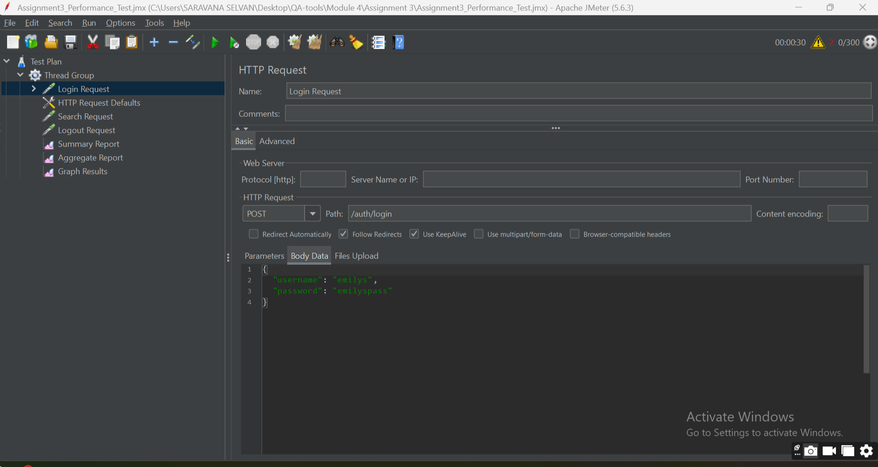
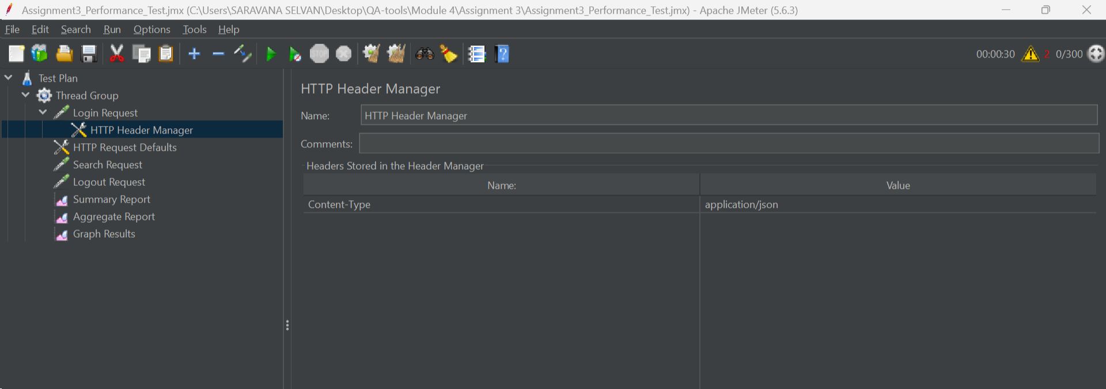
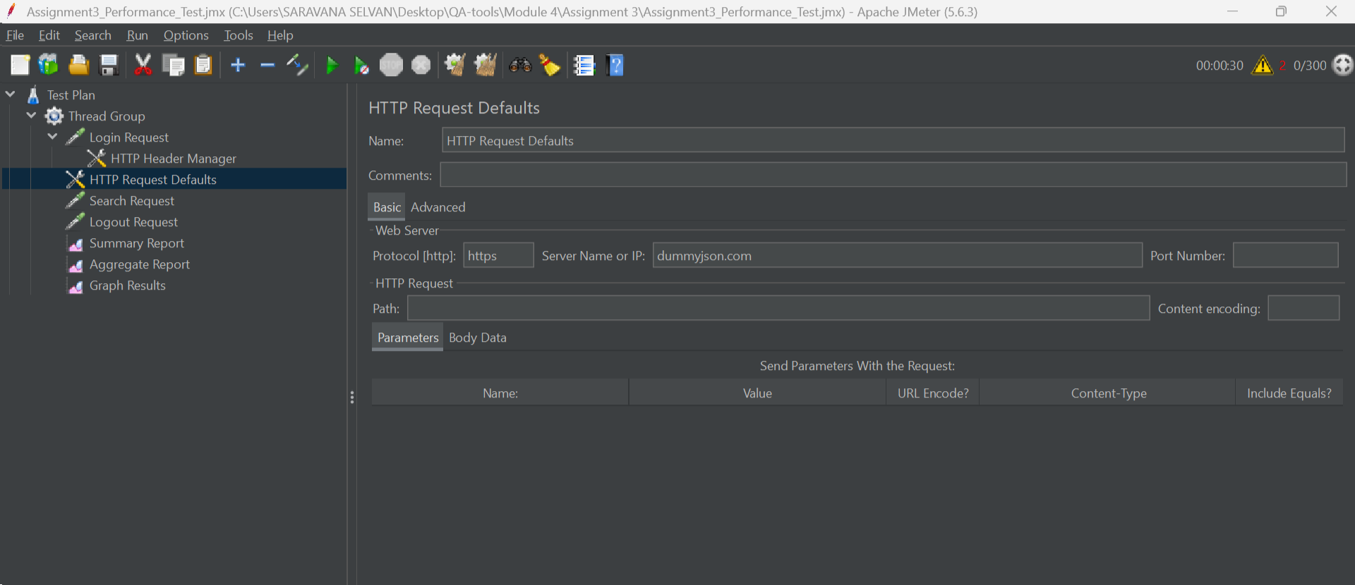
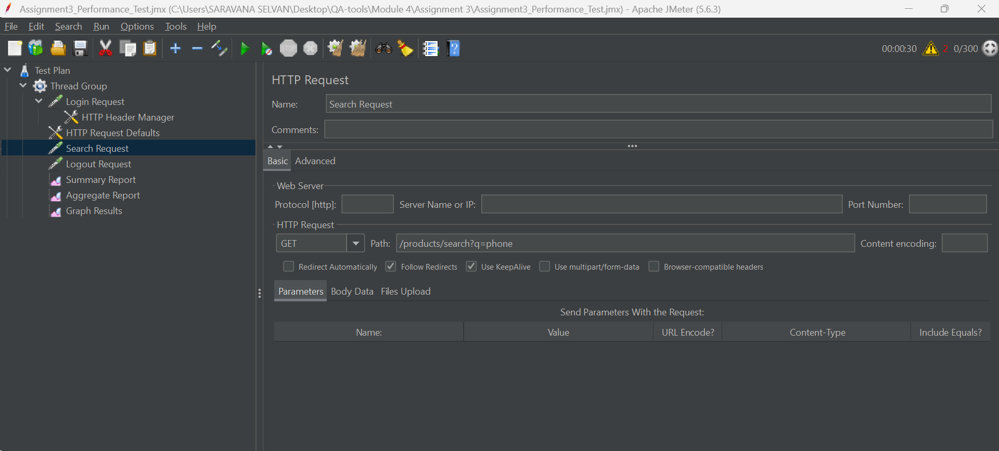
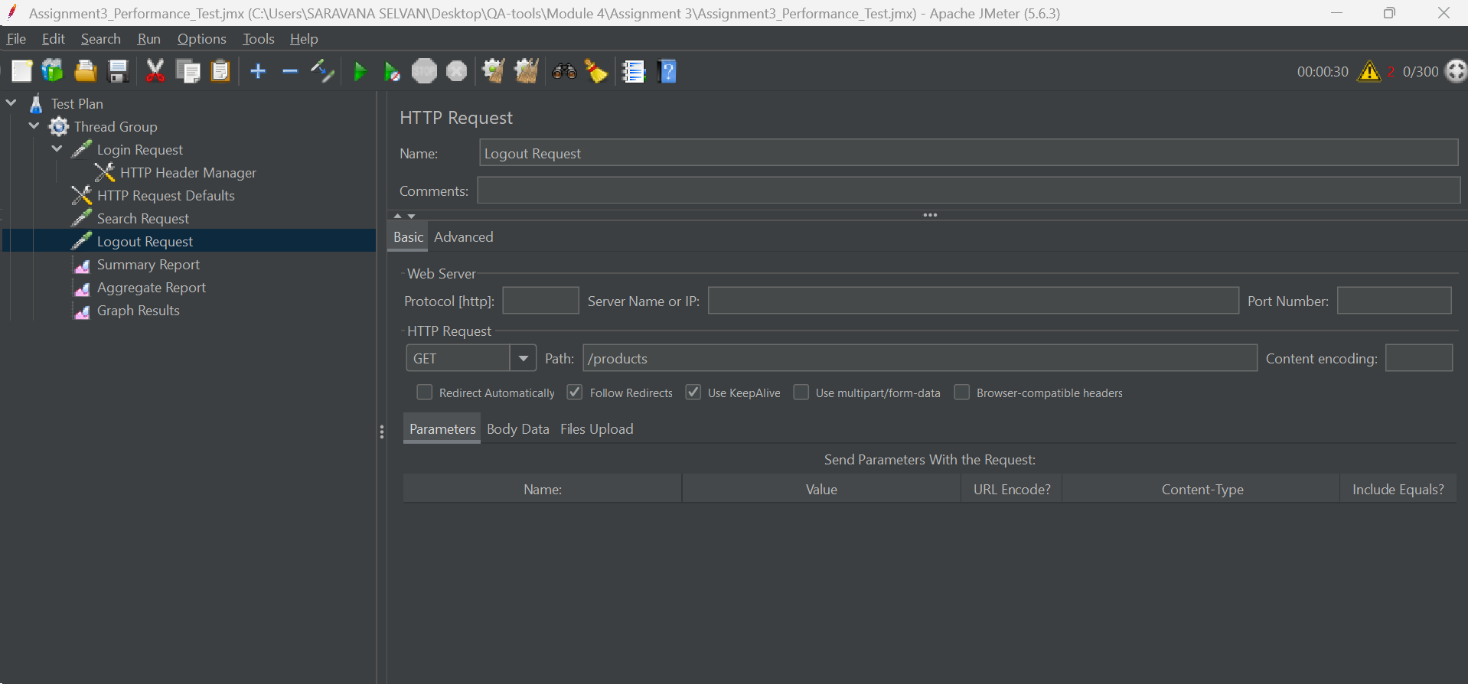
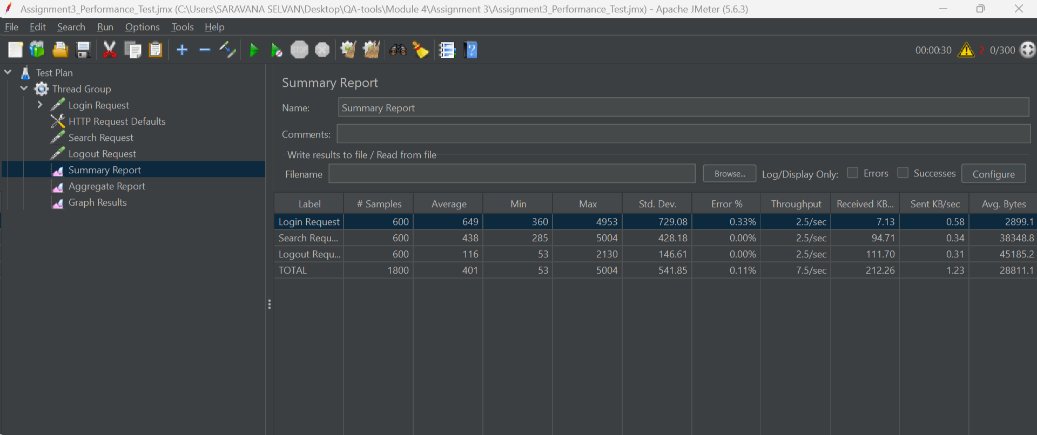
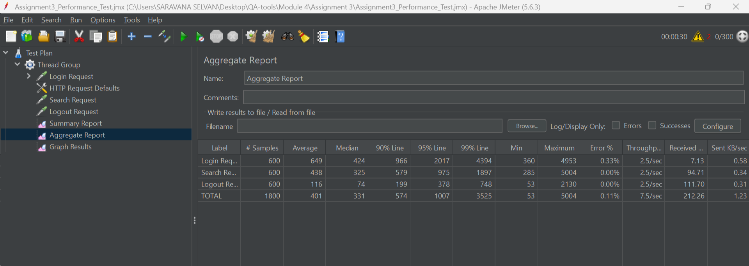
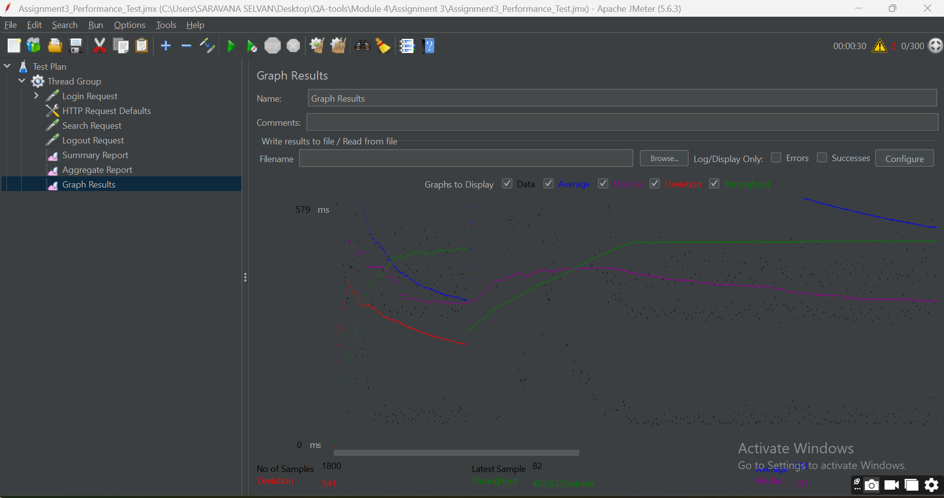
Recommendations based on performance testing:
- Optimize database queries to reduce response time.
- Increase server resources (CPU and RAM) if the server is overloaded.
- Implement caching to improve response times.
- Use load balancing to distribute incoming requests.
- Optimize APIs and application code to reduce latency.
- Monitor server logs to identify bottlenecks and errors.

Assignment 4
Objective
Validate the login functionality of a Cisco Wireless Controller Web UI.
Workflow
Open Browser
Navigate to URL
Enter Username
Enter Password
Click Login
Verify Dashboard
Simple Python Selenium Code
from selenium import webdriver
from selenium.webdriver.common.by import By
from selenium.webdriver.support.ui import WebDriverWait
from selenium.webdriver.support import expected_conditions as EC
from selenium.webdriver.chrome.service import Service
from webdriver_manager.chrome import ChromeDriverManager

# Launch Browser
driver = webdriver.Chrome(service=Service(ChromeDriverManager().install()))
driver.maximize_window()

# Open URL
driver.get("https://opensource-demo.orangehrmlive.com/web/index.php/auth/login")

wait = WebDriverWait(driver, 10)

# Enter Username
wait.until(
EC.visibility_of_element_located((By.NAME, "username"))
).send_keys("Admin")

# Enter Password
driver.find_element(By.NAME, "password").send_keys("admin123")

# Click Login
driver.find_element(By.XPATH, "//button[@type='submit']").click()

# Verify Dashboard
dashboard = wait.until(
EC.visibility_of_element_located((By.XPATH, "//h6[text()='Dashboard']"))
)
if dashboard.is_displayed():
print("Login Successful - Dashboard Verified")
else:
print("Login Failed")

driver.quit()
Test Steps
Step | Action | Expected Result
1 | Open Browser | Browser opens
2 | Navigate to URL | Login page displayed
3 | Enter Username | Username entered
4 | Enter Password | Password entered
5 | Click Login | Login successful
6 | Verify Dashboard | Dashboard displayed

Since a real Cisco Wireless Controller Web UI is not available, the same Selenium login flow is demonstrated using the OrangeHRM demo application. The automation logic is identical; only the URL and element locators would change for the actual Cisco application.
Assignment 5
1. Is the application meeting customer requirements?
No.
The application does not meet the customer's performance requirements because:
The average response time is 4.5 seconds, which is more than the required 2 seconds.
The error rate is 12%, which is much higher than the acceptable 1%.
Therefore, the application fails to satisfy the customer's expectations.
2. Which metrics indicate a problem?
a) Average Response Time
Actual: 4.5 seconds
Required: Less than 2 seconds
Problem: The application is responding too slowly.
b) Error Rate
Actual: 12%
Required: Less than 1%
Problem: Many user requests are failing, indicating poor application stability.
c) Throughput
Actual: 120 requests/second
Although the throughput looks reasonable, it is not enough because the application is producing slow responses and a high number of errors.
3. Possible Causes
- The poor performance may be caused by:
- High server CPU or memory usage
- Database queries taking too long
- Too many concurrent users (500 users)
- Network latency
- Insufficient server resources
- Application code not optimized
- Connection pool or thread pool limitations
4. Recommended Next Steps
- To improve the application performance:
- Monitor server CPU, memory, and disk usage.
- Analyze slow database queries and optimize them.
- Review application logs to identify the cause of errors.
- Increase server resources if required.
- Optimize application code and APIs.
- Tune connection pools and thread pools.
- Run JMeter tests again after making improvements.
- Continue performance testing until:
- Response Time is less than 2 seconds
- Error Rate is less than 1%
Conclusion
The JMeter test results show that the application does not meet the customer requirements. The response time (4.5 seconds) and error rate (12%) exceed the acceptable limits. Performance tuning, server optimization, database improvements, and further load testing are required before the application is ready for production.
Assignment 6
Scenario
A REST API is available to retrieve all connected Access Points.
API Endpoint:
GET /api/accesspoints
Answer
1. HTTP Method
GET
Reason:
The GET method is used to retrieve information from the server without modifying any data.
2. Request URL
If the base URL is:
https://example.com
Then the complete request URL is:
GET https://example.com/api/accesspoints
3. Expected Status Code
200 OK
This indicates that the request was processed successfully and the Access Point information was returned.
4. Expected Response Format
Expected response in JSON format.
Example:
{
"accessPoints": [
{
"id": 1,
"name": "AP-101",
"status": "Connected",
"ipAddress": "192.168.1.10"
},
{
"id": 2,
"name": "AP-102",
"status": "Connected",
"ipAddress": "192.168.1.11"
}
]
}
5. Three Validations
Validation 1 – Status Code
Verify the response status code is 200 OK.
pm.test("Status code is 200", function () {
pm.response.to.have.status(200);
});
Validation 2 – Response Time
Verify the response time is less than 2000 ms.
pm.test("Response time is less than 2000 ms", function () {
pm.expect(pm.response.responseTime).to.be.below(2000);
});
Validation 3 – Response Contains Access Points
Verify the response contains the accessPoints array.
pm.test("Access Points list exists", function () {
var response = pm.response.json();
pm.expect(response.accessPoints).to.be.an("array");
});
Postman Request
Field | Value
Method | GET
URL | https://example.com/api/accesspoints
Authorization | Bearer Token (if required)
Headers | Content-Type: application/json

Screenshot :
As there is no actual endpoint given I have provided the dummyJSON endpoint which shows HTTP method, Status code and Response type.


